AirBnbDatamart
From app concept to open source program

Development Phase



Further training project of
https://www.iu-akademie.de

Project by
Björn Leue, *25.11.1985
iu akademie e-mail: bjoern.leue@iu-academy.org
personal e-mail: webmaster@wildsite.de

Last editing: 28.03.23

Contentlist

Development Phase - Lookover 1

Files 2

Folders 3

Starting app by commandline / terminal 4

Using app by webinterface 5

The Webinterface 6

To-do's 7

Development Phase – Lookover

I started to write code to control the app, so i created the AirBnBDatamart.py file.
In this file the app get all the given attributes and handle it.
When i give the attributes
action=UserLogin username=testuser password=password
it start's the function login_user, given in sqlite.py.
In that function, i start a function for searching in the SQLite database and give back some data, if there are the given user and the given password.
The possible attributes for all actions you'll find in the README.md.

I developed it for Windows and Linux systems.

I used the graphical userinterface of the projects that i wrote before. So i had just to make some replacements.
The hardest problem was to find the problems with the sql querys. Sometimes i had bad fictive generated data and one time it was a failure in a query. But when you read it thousand times you don't see it.. Next day i saw the failure in a database join, i setted the wrong column...

Files

AirBnBDatamart.py
The main file which take the attributes for running this app, create database if not exists

airbnb.db
The database with some fictive data

files.py
Some functions for do some actions with files

globals.py
Some universal true variables, like what's the path of AirBnBDatamart.py

README.md
The documentation for installing and using this app

requirements
Required classes for installing
settings.json
The bones of the settings for running the app
settingsChanger.py
A function that takes the given attributes to a copy of settings.json. With that handle the whole program.
sqlite.py
Some functions that make it easier to write queries to SQLite
system.py
Some functions that return operating system specific data like the type of operating system

server.py
A webserver, that serve the pages in the templates folder on port 5000

Folders

Documents
The documents that i've written for the further training

static
Given by simpleHtmlServer standard settings, i had to take the asset files to this folder

html_templates
The templates that i reload, when the dropdown form input was changed

js
Some javascript for animations and so on

css
The CSS files for the style of the webpage

images
The images from the uploads, stored in the database

assets
Images, gifs, and so on for the webpage

templates
Given by simpleHtmlServer standard settings, i had to take the main HTML files to this folder

Starting the app by commandline
First download the resources from the repository and unzip it to a folder where you want to place it.
Windows:
First steps:
Press the Windows-key and type „cmd“, then the Enter-key.
Change to the folder where you placed the app („cd C:\Python\AirBnBDatamart“, Enter- key).
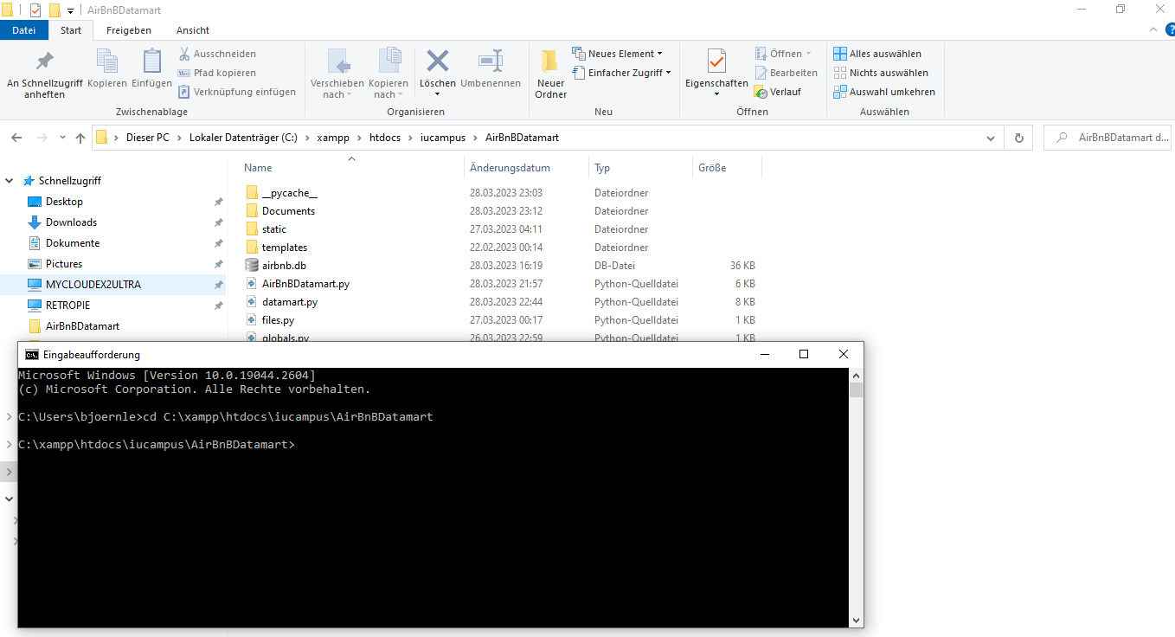

Linux:
First steps:
(Press „Alt“ + „T“ to open a terminal.)
Change to the folder where you placed the app („/usr/USERNAME/AirBnBDatamart“)

Use the app

For example to running an local server, type the following, otherwise look to README.md.
python AirBnBDatamart.py action=StartServer

Starting the app with webinterface

See the „first steps“ for your operating system, seen at „Starting app by commandline“
Then type something like..
python AirBnBDatamart.py action=StartServer
Voila!
Another commandline will be opened, that will serve the app in your local network.
Additionally the standard webbrowser will be opened with the ip where you find the app.
That means, now you're able to use the app without typing so much and with better input control in your whole home-network, if you're connected to your router.
Login to the app
For first tests you could use the credentials
Username: Alexander
Password: password1
But you're able to add a user by commandline, after that you could login with that profile.
python AirBnBDatamart.py action=SignupUser username=USERNAME password=PASSWORD

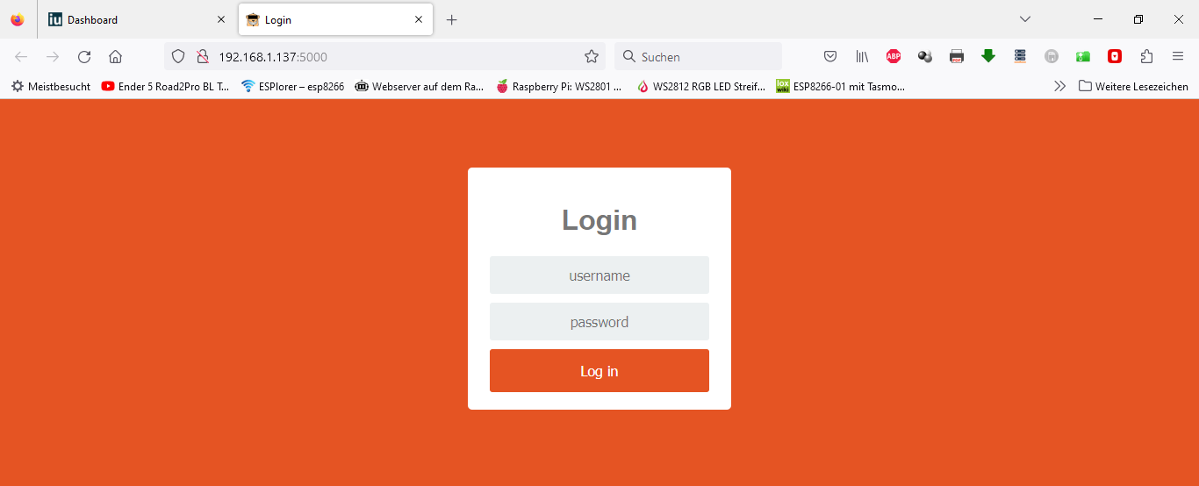
Web userinterface
Login

Startpage
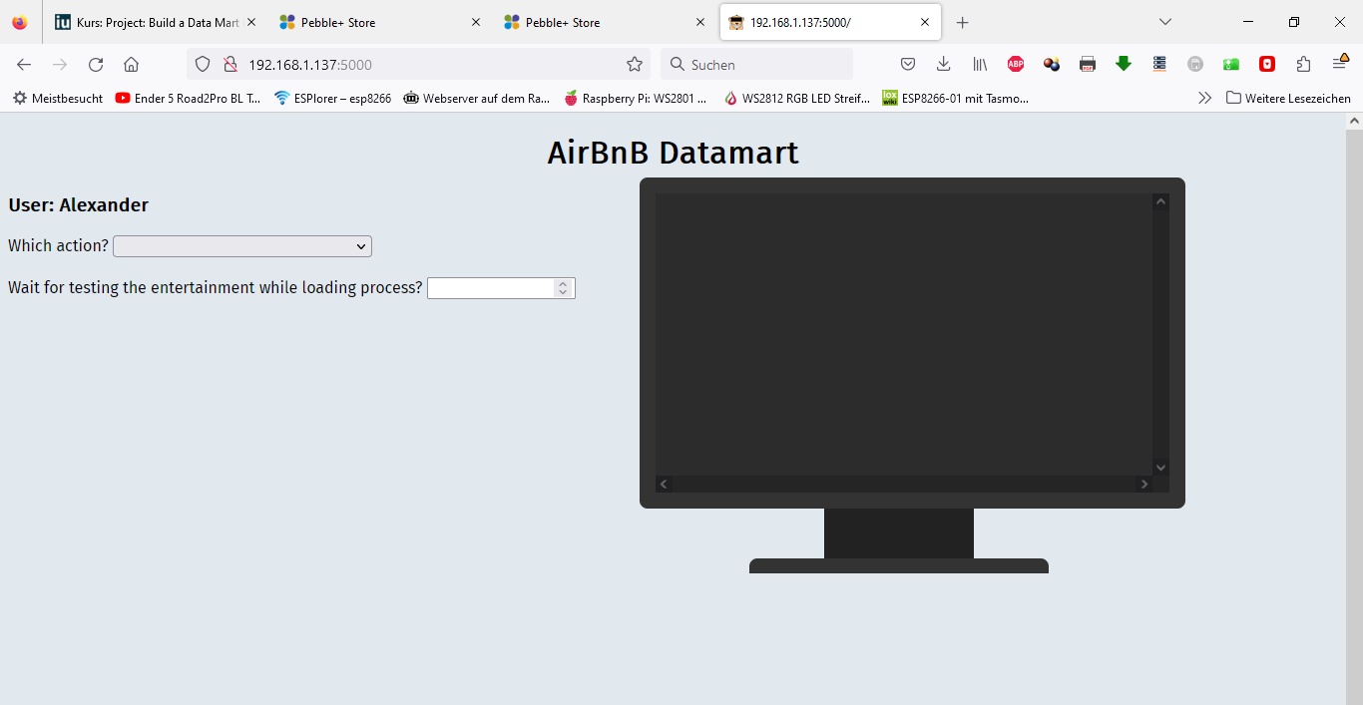
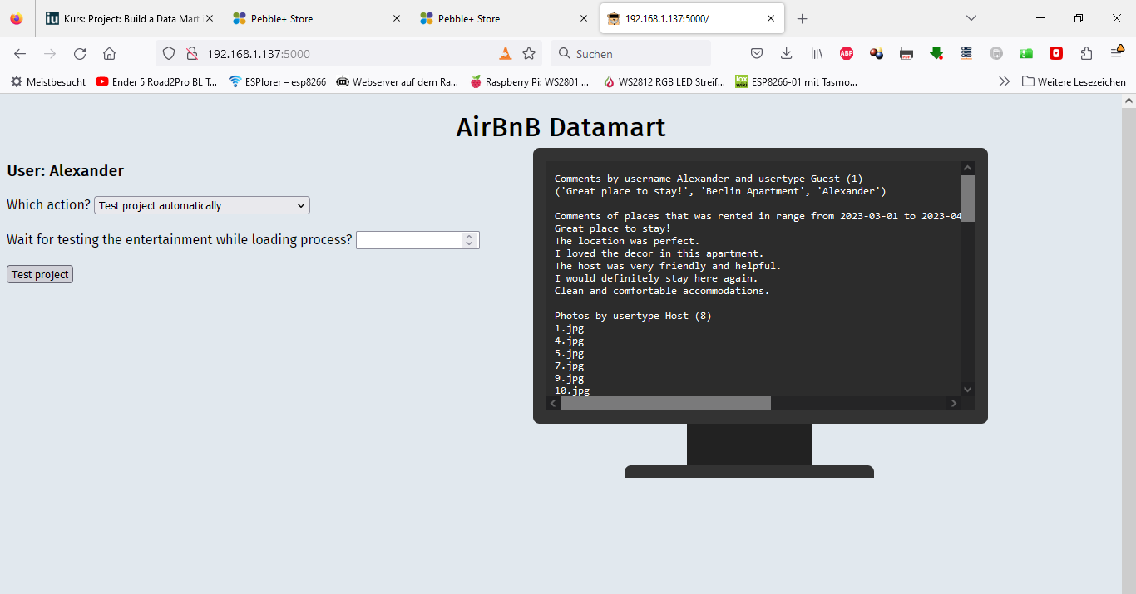
Done request

To-Do's

Take all to universal text translation (a proplem that was shown by the unknown char (?) in the monitor. It's the UTF8 char for the hyper 3 instead of the space char.
(just to replace (for fast troubleshooting), but for universal translating not the end of the line)
Create a class for user roles and authorization for functions.
Complete the userinterface with implementation of that auth class.
Create a better template for using the app. (I created the possibillity that the python functions return json instead text, for HTML views)
…
and become version 1.0...
…

